*Online Movie Ticketing System*

The Online Movie Ticketing System, named MovieMagic, is a web application developed using the Django framework in Python. This project serves as part of the Business Application Development module at the Faculty of Business, University of Moratuwa. To get started, users need to install the required dependencies using the pip package manager. The primary dependencies are Django and Pillow, with Django being the core web framework for the application, and Pillow providing image processing capabilities.

Once the dependencies are installed, users can proceed with database setup and migration by executing the `py manage.py migrate` command. After successfully setting up the database, the local development server can be initiated using the `py manage.py runserver` command. Users can then access the MovieMagic web application by navigating to "http://127.0.0.1:8000" or "localhost:8000" in their web browser.

The web application includes an Admin Panel for managing the system, and the provided credentials for accessing the Admin Panel are username: "Nithi1999" and password: "MovieMagic99". The project was originally created by Pahirathan Nithilan and has been modified by T.Viploon, T.Akulapiriyan, and W.Robina, each contributing to the development and enhancement of the application.

# *About this project*

In the MovieMagic project, we have developed a comprehensive Online Movie Ticketing System using the Django web framework. This system provides users with a seamless platform to explore and book movie tickets online. The website is structured with various views, each serving a distinct purpose. The "index" view showcases the currently available movies, while the "upcoming" view displays movies that will be released in the future.

For user interaction, we have implemented a user authentication system with a login and signup functionality. Users can register for an account through the "signup" view, providing essential details such as email, name, mobile number, age, and the number of seats they wish to book. The registered users and their booking information are stored in the database, and the booked tickets can be viewed through the "booked" view.

Detailed information about each movie, including its name, image, release date, duration, genre, language, rating, cast, trailer link, and pricing, is available on the "details" and "updetails" views. Users can navigate to these views to get more insights into their favorite movies.

Additionally, the project includes an "about" page that provides more information about the MovieMagic system. This page serves as a space to communicate the project's background, its purpose, and any additional details that users may find interesting.

The project's architecture is structured to be easily manageable through the Django admin panel, where administrators can oversee and manipulate movie details, user registrations, and other essential aspects of the system.

Overall, MovieMagic aims to streamline the process of booking movie tickets, offering users a user-friendly interface to explore, select, and reserve tickets for their preferred movies.

# *Database*

The MovieMagic project utilizes a SQLite3 database to manage and store essential data for seamless functioning. The database consists of three main tables, each corresponding to different aspects of the movie ticketing system.

The "movies" and "movies2" tables store details about the movies available in the system, including information such as the movie name, release date, duration, genre, language, rating, cast, trailer link, and pricing. The tables are designed to accommodate both currently playing movies and upcoming releases, allowing for a dynamic and flexible representation of the available film catalog.

The "reg" table is dedicated to user registration and booking information. It stores user details, including email, name, mobile number, age, and the number of seats booked. This table facilitates the tracking of user bookings, enabling users to view their reserved tickets through the "booked" view.

The database structure aligns with the Django models defined in the "models.py" file, ensuring a consistent and organized representation of data. This relational database system plays a crucial role in maintaining the integrity of the MovieMagic system, enabling efficient data retrieval and management through Django's powerful ORM (Object-Relational Mapping) capabilities.

*Screenshot*

***Home Page:***

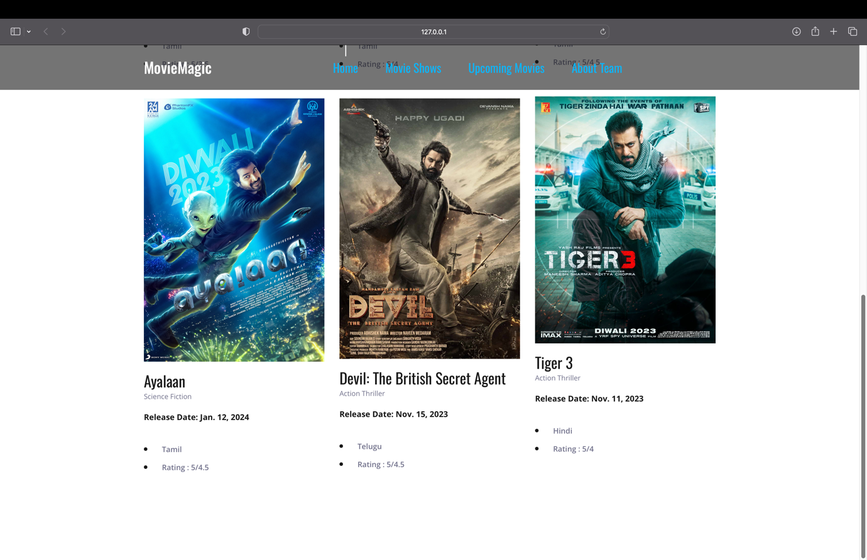

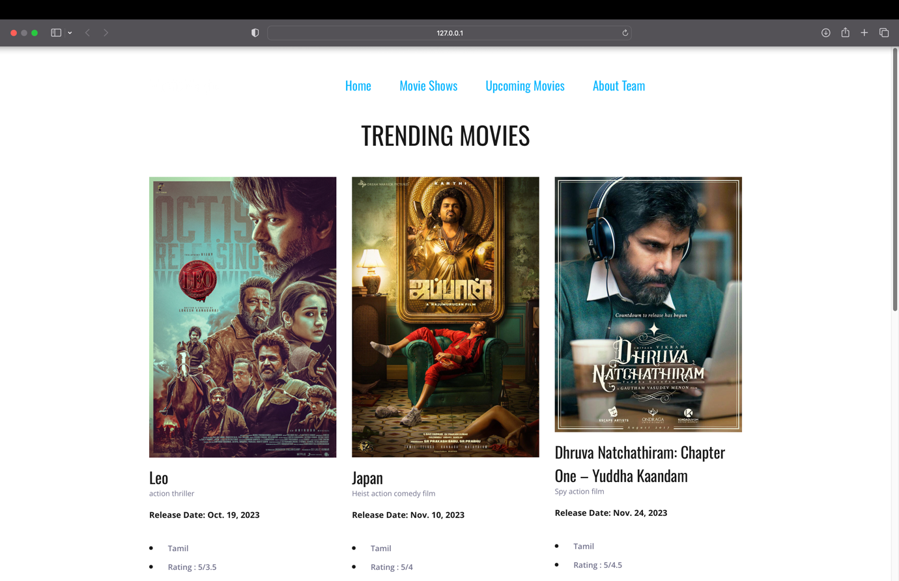

The provided HTML code appears to be a template for a website named "MovieMagic," focusing on trending and upcoming movies. The structure includes standard HTML tags, incorporating Bootstrap for styling and responsiveness. The header features a navigation bar with links to different sections like home, movie shows, upcoming movies, and an about team page. The main content section dynamically displays either "Upcoming Movies" or "Trending Movies" based on a condition. For each movie in the provided data (presumably from a backend), it generates a card with details such as the movie's name, type, release date, language, and rating. The design is clean, utilizing images and concise information for each movie. The code also includes JavaScript imports for various functionalities, suggesting a dynamic and interactive user experience. Overall, the template seems well-organized and designed for showcasing movie information in a visually appealing manner.

***Upcoming Page:***

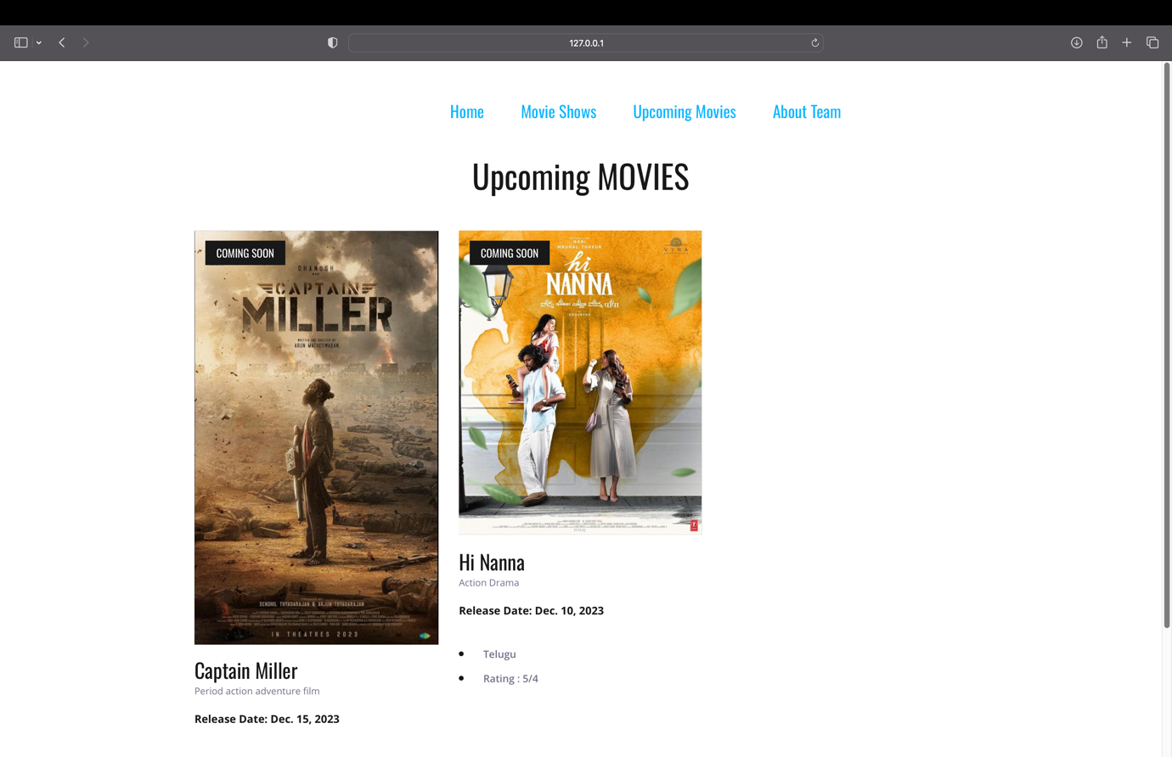

The "upcoming.html" file appears to be an HTML template for a webpage related to trending movie shows on a site named "MovieMagic." The template includes a navigation bar with links to different sections such as home, movie shows, upcoming movies, and an about team page. The main content of the page focuses on upcoming movies, displaying them in a grid layout with images, names, types, release dates, languages, and ratings. Each movie entry also has a "COMING SOON" special offer tag. The template is designed with a responsive layout, making it suitable for various devices. It utilizes popular front-end technologies like Bootstrap, Font Awesome, and Owl Carousel for styling and interactive elements. Overall, the template provides a user-friendly interface for users to explore and discover upcoming movies on the MovieMagic platform.

***About Page:***

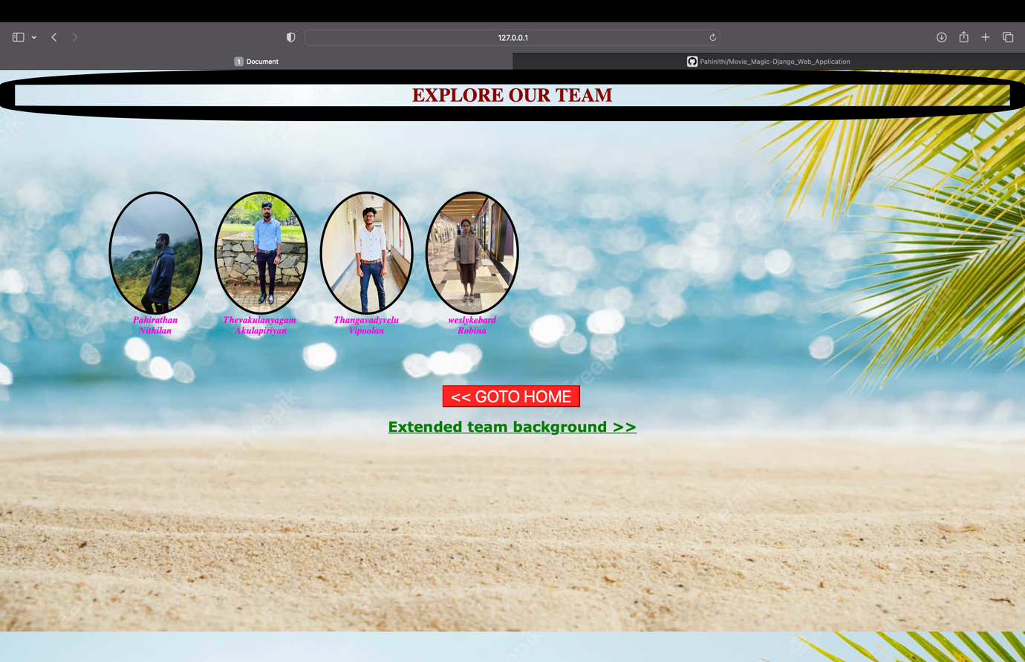

The provided HTML document appears to be a webpage template designed for showcasing a team and providing links for navigation. The page features a stylish button with hover effects and a link to return home. The background is set with a dynamic image, and team members are displayed in boxes with images and names. Each team member's information is presented in a consistent format with a colored text style. Additionally, there is a link to access more extended information about the team. The overall design suggests a visually appealing and user-friendly interface for exploring and learning more about the team members.

***Team information page:***

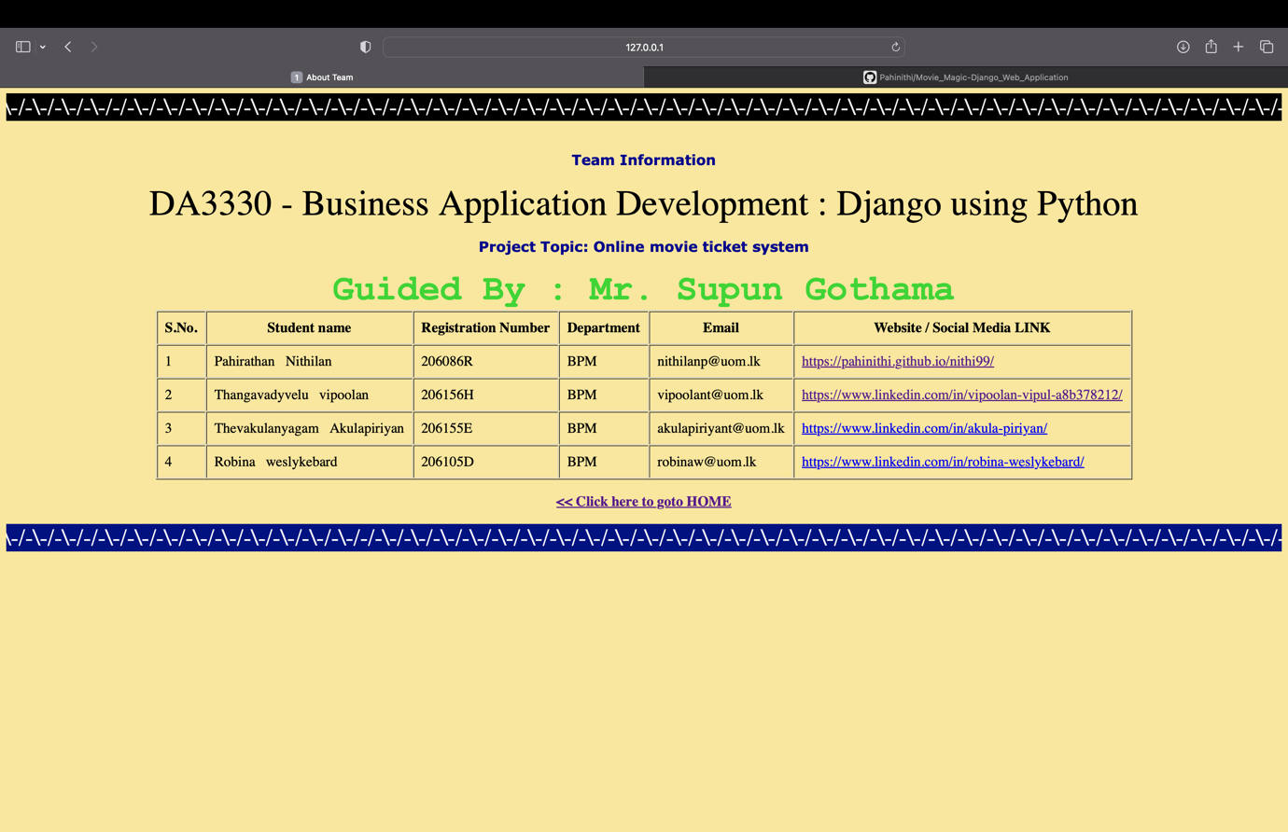

The "about.html" file appears to be an HTML document containing information about a team and their project on business application development using Django and Python. The page includes dynamic content through the use of Django template tags. The styling is defined using embedded CSS, with attention to button animations and a blinking text effect. The content of the page provides details about the project, including its topic, the guiding instructor (Mr. Supun Gothama), and information about each team member. Each team member's details are presented in a table format, including their name, registration number, department, email, and links to their respective websites or social media profiles. The page also features marquee elements with scrolling text to add visual appeal. Additionally, there is a button with a hover effect that encourages users to navigate back to the home page. Overall, the page combines both functional and visually engaging elements to present information about the team and their project.

***Movie Details Page:***

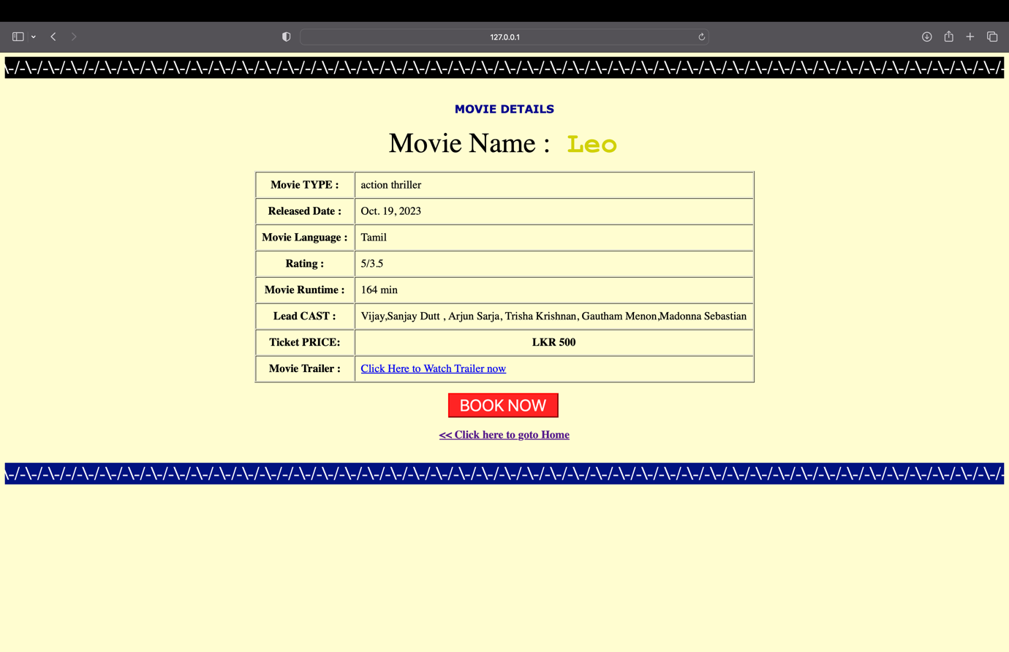

The provided HTML code appears to be a template for displaying details about a movie on a web page. The page includes various style elements for buttons and text, creating an aesthetically pleasing interface. It utilizes the Django templating language to dynamically insert movie details such as name, type, release date, language, rating, duration, cast, price, and a link to the movie trailer. The use of marquee tags adds scrolling effects to the top and bottom of the page, enhancing its visual appeal. The page also features a button to redirect users to a signup page and a link to return to the home page. Additionally, there's a blinking effect applied to the movie name for attention-grabbing emphasis. Overall, the HTML code seems well-structured for presenting movie details in an engaging and user-friendly manner.

***Booking Page:***

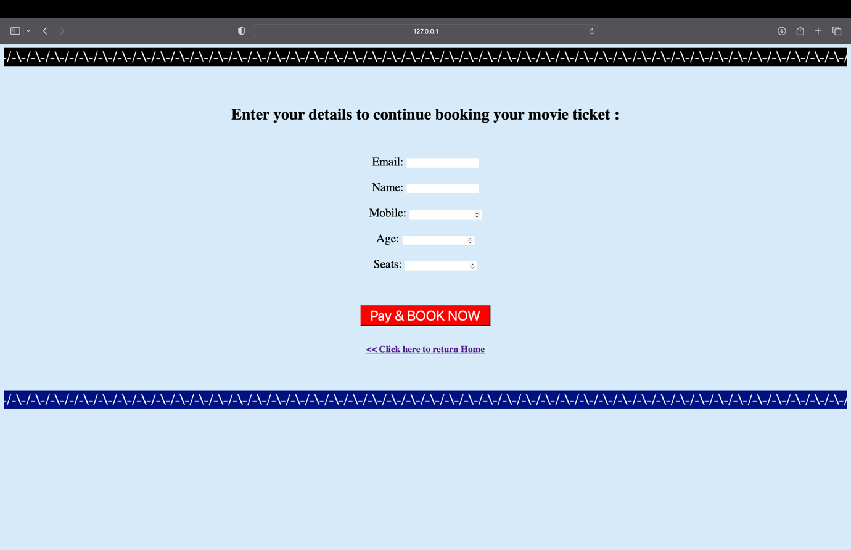

The `models.py` file provided defines three Django models for a movie ticket booking system. The first two models, `movies` and `movies2`, represent movies with fields such as name, image, release date, duration, type, language, rating, cast, trailer, an 'up' boolean indicating whether the movie is currently showing, and a price. The third model, `reg`, is designed for user registration and stores information such as email, name, mobile number, age, and the number of seats booked. The models are structured to capture essential details about movies and user registrations, facilitating the development of a web application for booking and managing movie tickets. The use of Django's built-in `User` model suggests integration with the authentication system for user management.

***Booked success page:***

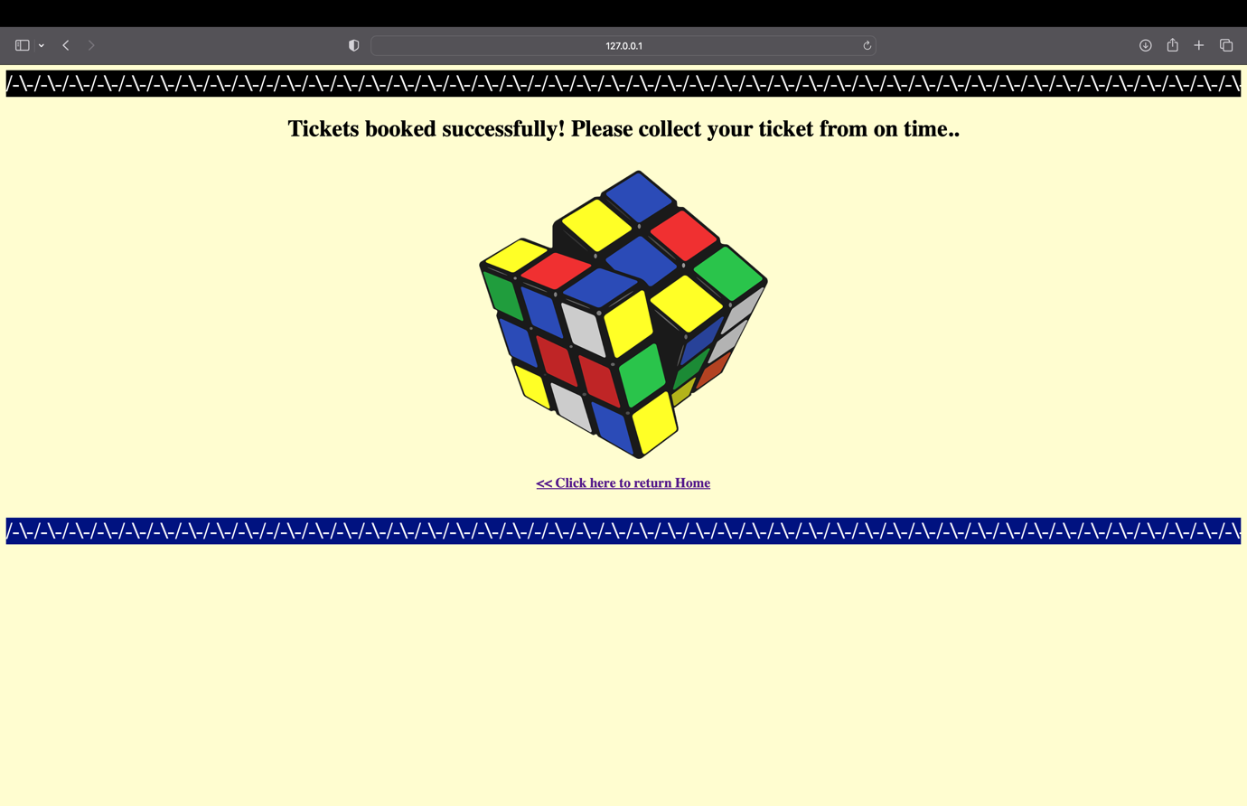

The "booked.html" file appears to be an HTML document containing a confirmation message for successfully booked tickets. The page has a visually appealing design with styling for a button, implemented with a hover effect and an animated blinking text. The use of marquee tags adds a dynamic touch with scrolling text at the top and bottom of the page. The central content includes a prominent header confirming the successful ticket booking, an image, and a hyperlink prompting users to return to the home page. The overall design is visually engaging, providing a positive and celebratory tone for users who have completed the ticket booking process.

***Admin panel:***

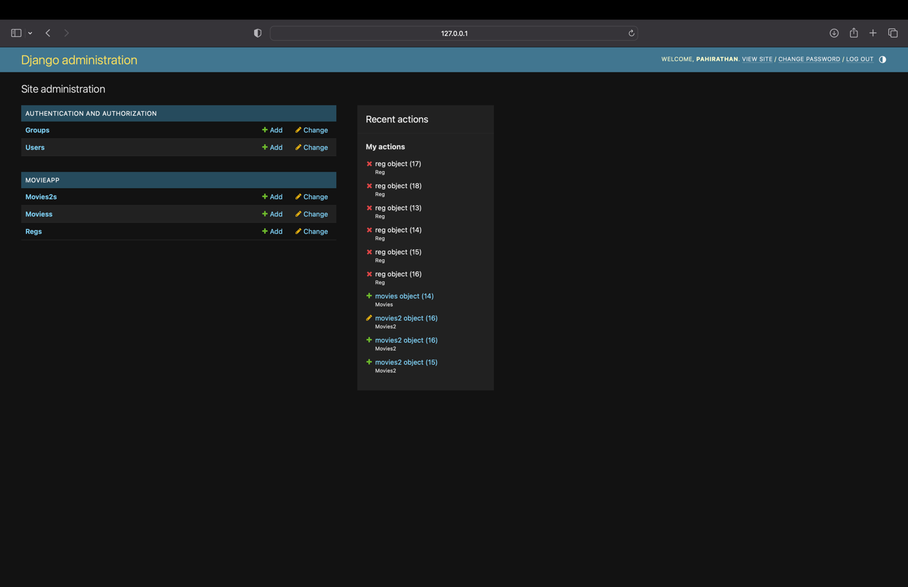

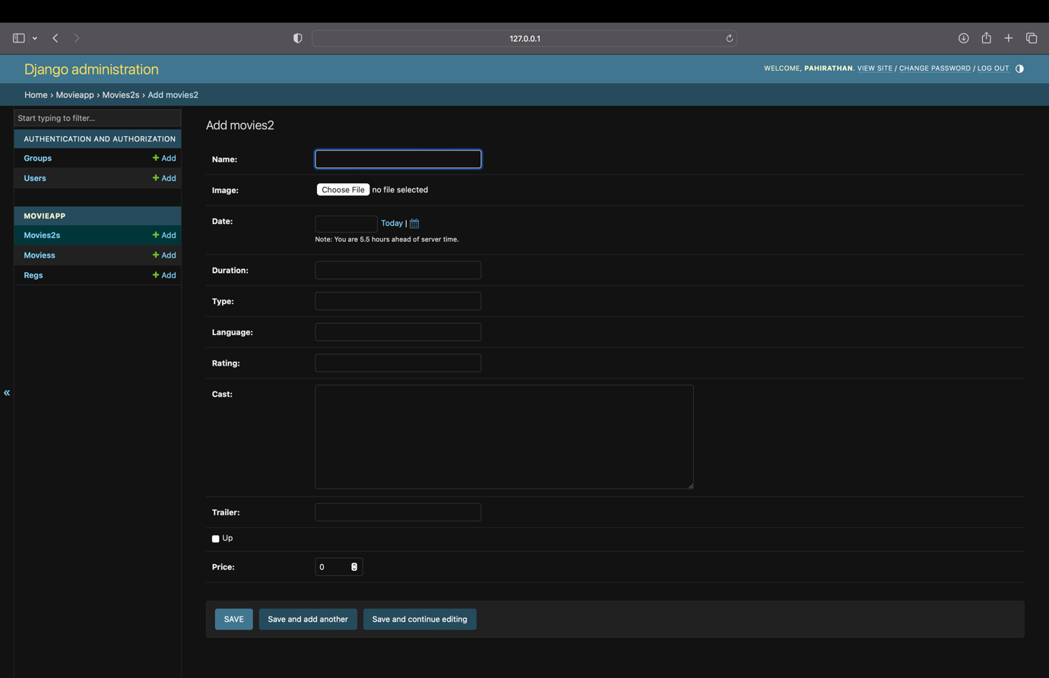

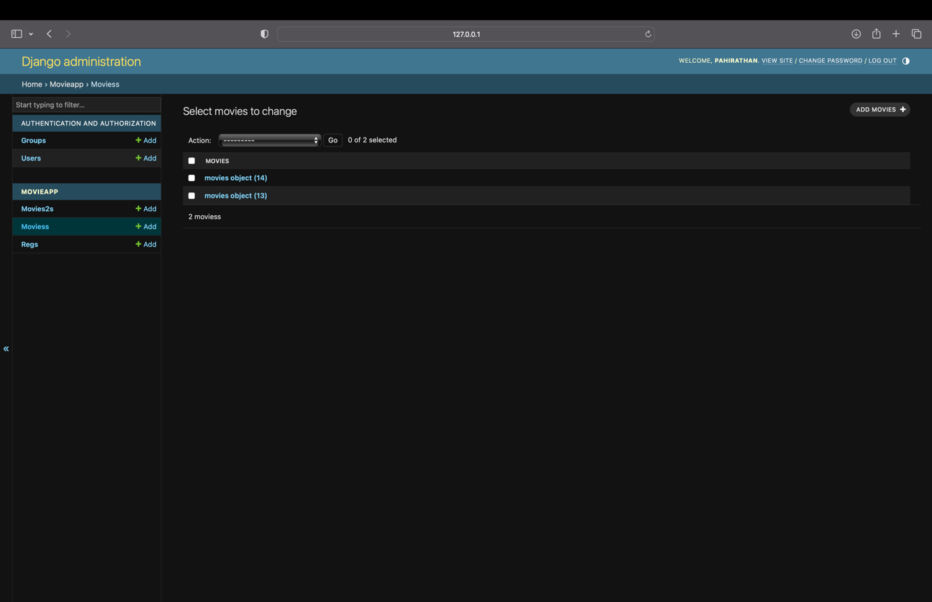

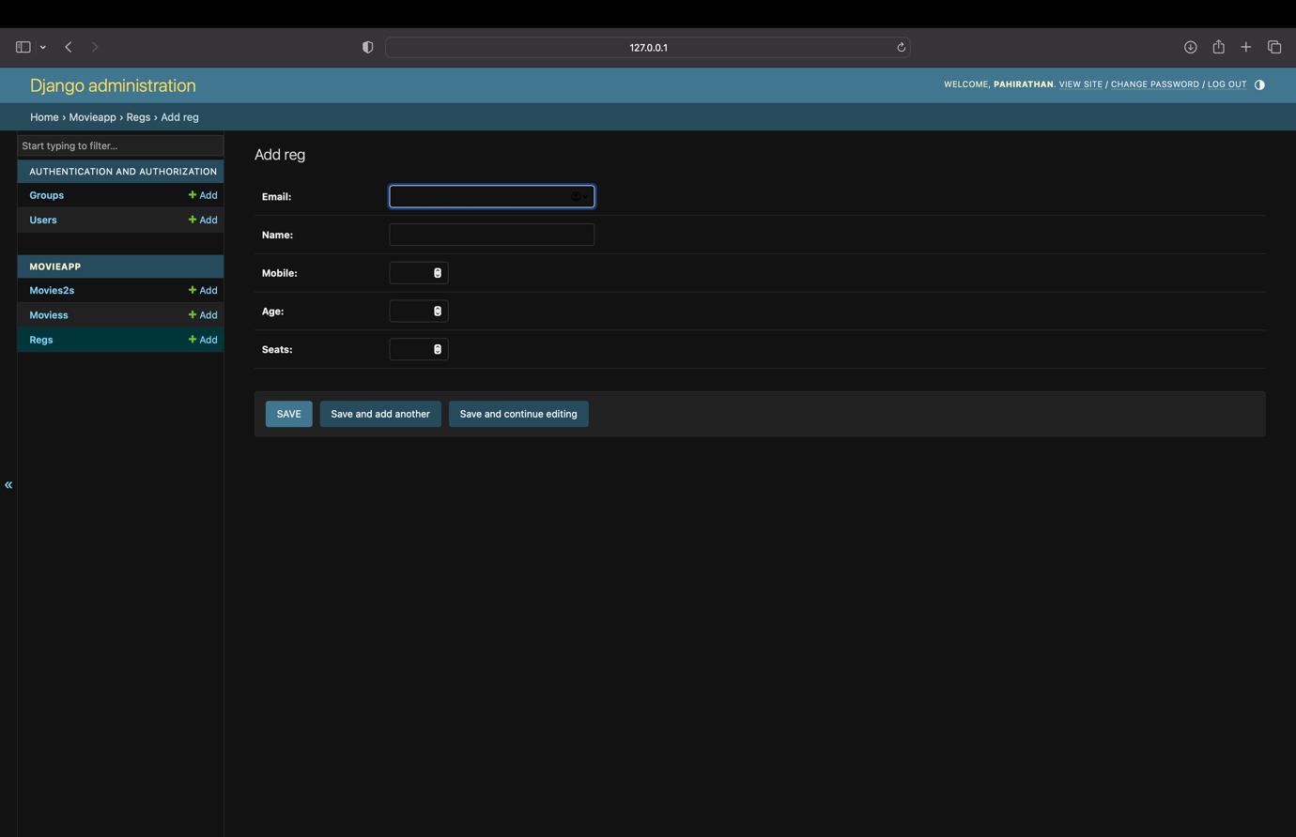

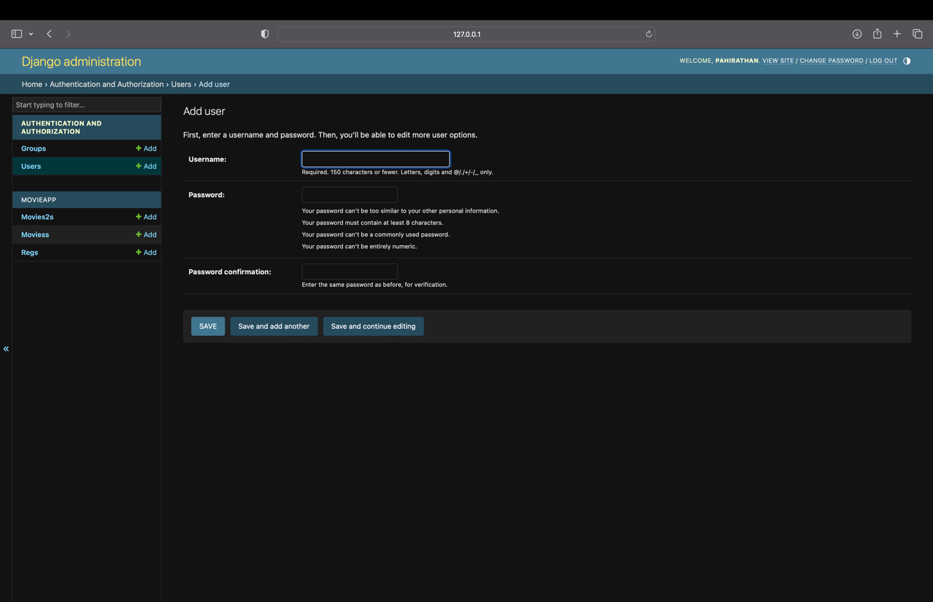

Video_Guide: [Click Me](https://drive.google.com/file/d/1e6f6r3S8RDpLlkJGw61YSvs8ww9hDPY_/view?usp=sharing)

Guide:

# Online-Movie-Ticketing-System

Web Application project for the Business Application Development module taught at Faculty of Business University of Moratuwa

# MovieMagic

MovieMagic website using Django (Python Web framework).

# Install all the dependencies:

> pip install django

> pip install Pillow

# After installation run the follwing Django commands :

> py manage.py migrate

> py manage.py runserver

# Visit "http://127.0.0.1:8000" or "localhost:8000" on your browser to view the django app.

# Admin Panel

User: Nithi1999

pwd: MovieMagic99

Thank You

P.Nithilan